**Linq Take Home Assessment:**

I have used Katalon Studio Automation tool to Automate the Linq welcome page

<https://katalon.com/download> This is the link by which katalon studio is downloaded and installed.

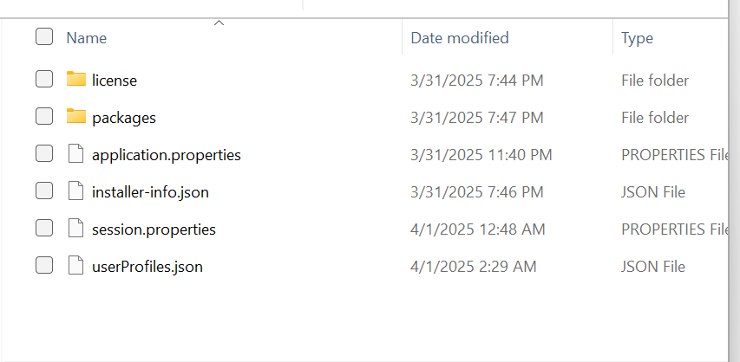All the folders like license, packages, application properties, installer information, session properties and user profile .json and property files are downloaded inbuilt when we download and install katalon studio.

There is no markdown file that can be setup in katalon studio so used word document to showcase everything.

There will be no external environment that should be setup for this automation tool.This is also compatible for all windows, macOS and Linux

* It is used to automate regression test cases mostly which doesn’t change can also automate when a new feature is introduced to check whether any regression test case is not working as expected.
* I chose this tool because it saves the test suits with the collection of test suits which are passed and failed.
* This tool saves the xpath of an element within the collection of the object repository where the xpath can be taken only once not all the time and can be used the test object any time multiple times which reduces the time.
* It is a multi-purpose automated tool where we can get the xpath by manually and create a test case manually and can record with less time and can also spy the certain element to automate and we can also use groovy script, and everything has its own advantage to execute
* For Reference I have created a test case using manually by finding xpath and creating a test object individually and evaluated it, and recorded the web page using record option
* This also has an option of importing selenium IDE project after executing
* As this contains OTP scenarios and QTP TESTING pages like email, apple twitter, linkedin so did not do more automation further
* Automated UI of few elements and few functionalities of the welcome page

**Bugs:**

**Bug1:**

**Bug Description:** If wrong OTP is given and without clicking on continue button wrong password popup is shown

**Steps to Reproduce**

1. Open the url <https://staging-web.linqapp.com/welcome>
2. Click on Phone Number Text field
3. Enter the mobile number
4. Click on Continue
5. Enter the wrong otp in next page
6. Observe new popup is seen without clicking on continue button like “Could not validate authentication code”

Note: This scenario is repeating wherever there is otp

**Expected behavior**: popup should not come until we click on continue button

**Bug2:** Post giving all details like name, job title, company name and mobile number if we click on back button user is not navigated to back screen.

**Steps to Reproduce:**

1. Open the url
2. Click on the Linq profile text which is located on the top left corner
3. Enter the email address in first text field where you see immediately upon opening
4. Click on Continue button
5. Give all the details like name, company name, phone number and job title
6. Click on back button and observe user is not navigated to the previous screen

Expected Behavior: All text fields should be cleared, and user should be navigated to previous screen

I have logged the bugs and put set up instructions in same file

CI Integration and committing to git by push command is also can be done using katalon studio which is inbuilt and can be run the test suite at any time

I wanted to provide an update on the CI integration for running Katalon test suites. While I am familiar with the process of setting up CI for Katalon using GitHub Actions, Jenkins, or other CI/CD tools, I have opted not to implement it at this stage due to the following reasons:

* Right now, my focus is on executing tests locally to validate core functionalities, refine the test scripts
* **CI Integration Overhead** – Setting up CI requires additional configuration, such as managing environment dependencies, handling execution logs, and maintaining test reports within the CI/CD system.